**TRANSFORMEE DE FOURIER RAPIDE FFT**

clc

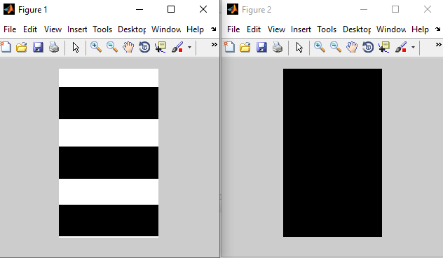

clear all

close all

I = imread('Test2.bmp');

figure(1), imshow(I)

Im=fft2(I);

Imod = uint8(abs(Im));

figure(2),imshow(Imod)